process synchronization

agar hamare system me multiple process run kr rahe hai toh us ke 2 mode hai

1. serial mode -> es me ek ek kr ke process execute hoge jisme jab tak ek terminate nhi hota dusara start nhi hoga
2. parallel mode -> es me kayi sare process simultaneously run kr rahe hote hai , or jab bahot sare process ek sath run karete hai toh ek bahot badi problem ati hai ki kuch process aise ho sakate ho ki cooperative processes ho or kuch process aise ho sakate hai ki independent process ho i.e here we categorize the process into 2 parts -
3. cooperative process -> yeh aise process hai toh ek ki execution dusare ke upar effect dal rahi hai because they share something or wo share kya ho sakata hai i.e they can share a common variable , they can share the memory (or buffer ) ,code or resouces(i.e variable hardware)
4. independent process - es me ek ki execution duare ke upar effect nhi dal rahi hai means un ke beech kuch bhi common nhi hai

ab process synchronization kam tab ata hai jab , jab cooperative process ko sahi se synchonize na kiya jaye so they can create problem (it is not madatory that the will but the can ) or yeh problem tabhi ati hai jab yeh parallel run kr rahe ho

yaha primitive process ko execute karane ke leye hum use karate hai function sleep(<time>), es se kya hoga ki wo process pause ho jayega , or dusare process ko switch kr sakate hai ,,

sleep(5); // means sleep for 5 sec

here because we conside uniprocessor system so first let say p1 runs and then after sleep its switches to process p2

as first we take shared value is 5 so if increase this value by one and decrease by one then answer should come 5 but here it comes as 4 because process is not synchronized and if p2 process first and then p1 then answer comes as 6, toh es problem ko hum bolate hai RACE condition (4 or 6 race laga rahe hai kon jitega but dono hi galata hai kyu ki hame answer 5 chahiye tha )

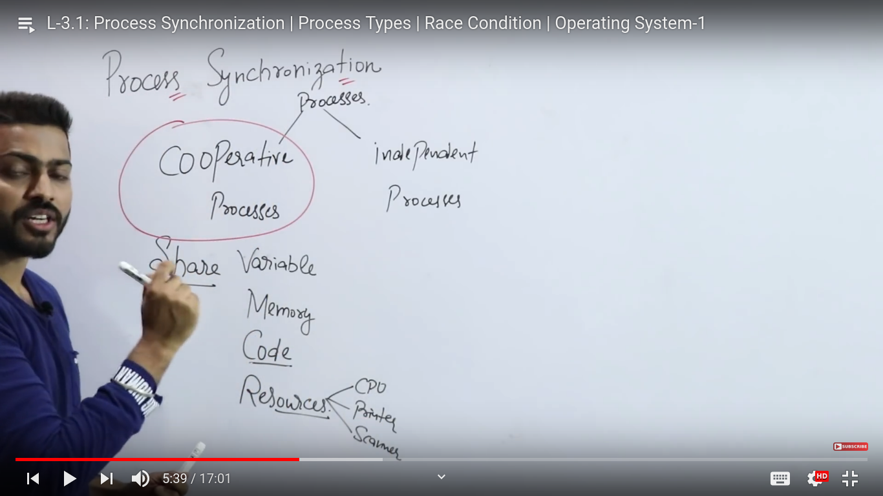

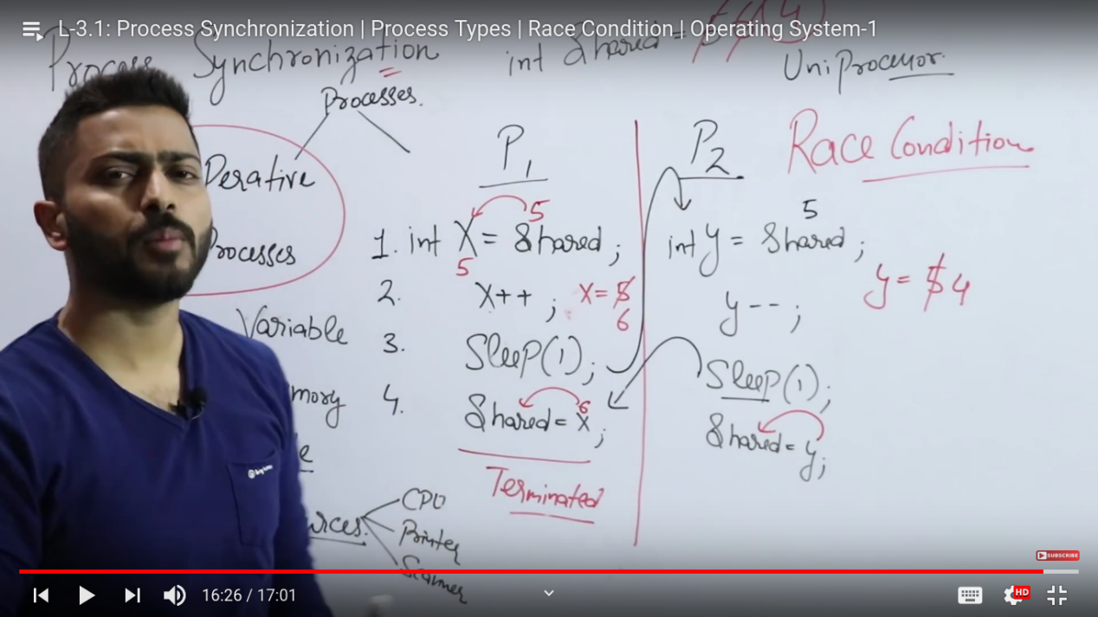

producer consumer problem :-

yeh ek standard problem hai multi process synchronization ki , mtlb es me hamare pass 2 process hai ek consumer ka process hai ek producer ka process hai and the assumption si dono processor ek hi time pe a rahe hai i.e both are parallel process nad they are sharing something i.e cooperative processes ki bat kar rahe hai

ab yaha pr ek consumer ka code li kha hua hai toh jab producer ka process run hota hai toh , toh producer ek item ko produce karata hai or us ko ek buffer me dalata hai or consumer kya karata hai item ko consume karata hai toh consume karane keleye pahale apana code ko execute karega or finally fir item ko buffer se bgahar nikalata hai , or us ko jo bhi process karana hai process kr sakata hai

as because when we run program toh us ke bahot sare cases ho sakate hai so we are checking now the cases in this

buffer jo hai jo dono process ke beech shared ho raha hai , or ek or chij share kar rahe hai i.e count variable

jo ki hum ne global variable banaya hai

case 1:- best case

